 | Documentation
Project Title: |  | Distributed Peer-to-Peer File Sharing System
Reg. No.: |  | DSAI231103094
Submitted by: |  | Faisal Qadir
Submitted to: |  | Sir Usman Shafeeq
Class/Section: |  | BS-AINT-6B
Subject: |  | Parallel and Distributing Computing Lab (PDC-Lab)

Abstract
The Distributed Peer-to-Peer (P2P) File Sharing System allows multiple computers (peers) to share files directly with each other without relying on a central server. Each node in the network acts as both a client and a server, enabling direct communication and resource sharing.
The system is implemented using Python socket programming and multithreading. It demonstrates distributed computing principles such as decentralization, concurrent communication, and fault tolerance. Users can request single or multiple files from other peers and download them efficiently.
This project is designed to give practical understanding of distributed systems, peer-to-peer communication, and network programming.

1. Introduction
Distributed computing involves multiple computers working together to perform a task. Unlike centralized systems, distributed systems share workload across nodes, reducing bottlenecks and increasing fault tolerance.
Peer-to-peer systems are a type of distributed system where each node can act as a client and a server. Popular real-world examples include BitTorrent, blockchain networks, and collaborative file-sharing platforms.
This project implements a basic Distributed P2P File Sharing System, highlighting the core principles of distributed computing, file sharing, and concurrent communication.

2. Problem Statement
Traditional file sharing systems often depend on central servers, which can become bottlenecks or single points of failure. If the server fails, the entire system becomes unavailable.
Objective: Design a decentralized file sharing system where peers communicate directly to share files, eliminating central dependency and demonstrating distributed computing concepts.

3. Objectives
- Implement a peer-to-peer file sharing system.
- Allow peers to discover available files on other peers.
- Support single and multiple file downloads.
- Demonstrate decentralized communication and concurrent execution.
- Test the system on multiple peers within the same network.

4. Tools and Technologies
- Programming Language: Python
- Networking: Socket Programming
- Concurrency: Threading Module
- Operating System: Windows
- Development Environment: Command Line / Terminal

5. System Architecture
The system follows a peer-to-peer architecture:
- Each node acts as both client and server.
- Peers communicate using IP addresses and port numbers.
- Files are requested and transferred directly between peers.
- No central server is required.
Architecture Diagram:
Peer 1 (Server + Client)
|
TCP/IP
|
Peer 2 (Server + Client)
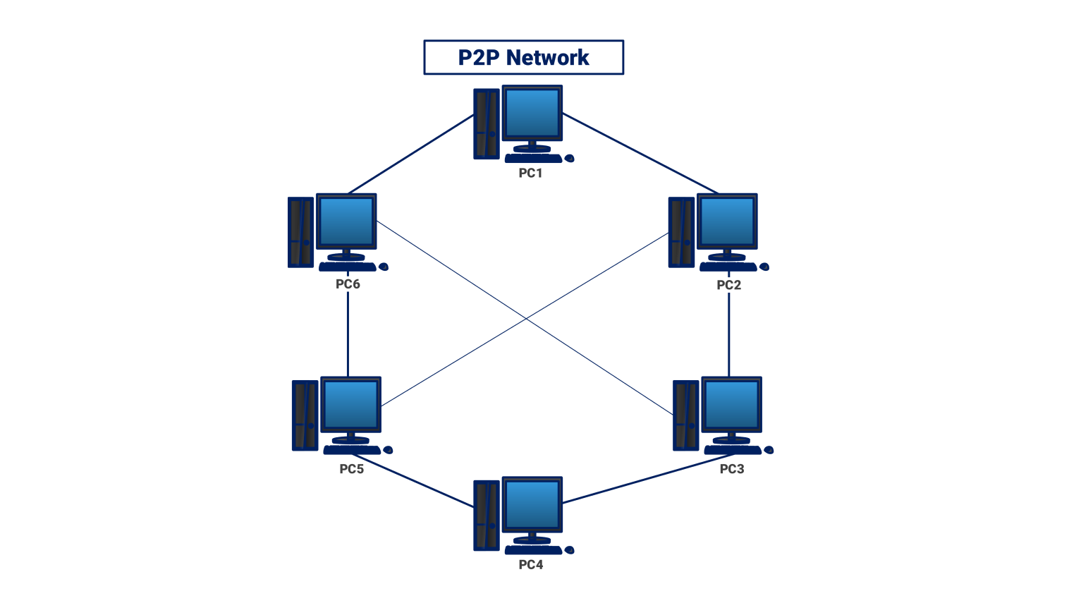
Each peer can:
- Listen for incoming file requests (server).
- Send file requests to other peers (client).
- Transfer files in parallel or sequentially.

6. Folder Structure
Each peer has the following folder structure:
peer
│
├── peer.py
├── shared_files
│ file1.txt
│ file2.txt
│ file3.txt
└── downloads
- shared_files: Contains files available for sharing.
- downloads: Stores files downloaded from other peers.

7. Implementation Methodology
The project is implemented using Python sockets with threading for concurrency.
Steps:
- Start peer server on a chosen port.
- Peer listens for incoming requests from other peers.
- Peer sends a "LIST" command to retrieve available files from another peer.
- User chooses single or multiple files to download.
- Peer sends requested files over the network.
- Files are saved to the downloads folder.
Concurrency:
- Multithreading allows peers to handle file requests and requests to other peers simultaneously.

8. Algorithm
For Peer Server:
- Start server socket on given port.
- Accept incoming connection.
- If request is LIST, send available file names.
- Else, split file names by comma and strip extra spaces.
- For each file, check if exists in shared_files.
- Send file data or "File not found" message.
- Close connection.
For Peer Client:
- Connect to peer using IP and port.
- If showing files, send LIST request.
- If downloading files, send comma-separated file names.
- Receive file data for each file.
- Save each file to downloads folder.

9. Testing and Experimental Setup
Network Setup:
Peer | IP Address | Port
1 | 192.168.0.101 | 5001
2 | 192.168.0.111 | 6001
Test Steps:
- Peer2 retrieves file list from Peer1.
- Peer2 downloads file1.txt.
- Verify files are present in downloads folder.
Expected Result:
- Correct file transfer between peers.
- File list shows all available files.
- Multiple file downloads work without errors.

10. Results
- Peer-to-peer communication successfully established.
- File list discovery works correctly.
- Single and multiple file downloads completed without errors.
- System demonstrates distributed computing principles: decentralization, concurrency, and fault tolerance.
- Peer server running
- File list shown
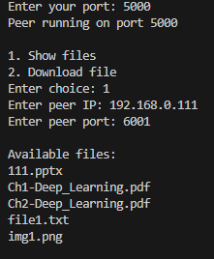
- files downloads

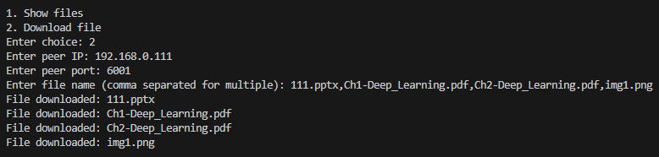

11. Distributed Computing Benefits
- Decentralization: No central server needed.
- Scalability: Additional peers can join easily.
- Fault Tolerance: Failure of one peer does not stop the system.
- Resource Sharing: Files and resources shared among multiple nodes.

12. File Sharing Technology Comparison
Technology | Speed | Range | Setup | Multi-file Support | Reliability | Best Use Case | Notes
TCP/IP (Wi-Fi / LAN) | Fast | ~100 m | Easy (IP + port) | Yes | Very stable | University lab, large files | Best option for this project
Bluetooth | Slow | ~10 m | Requires pairing | Possible but complex | Less stable | Small devices, short-range files | Good for small/mobile file transfer
USB / Direct Cable | Very fast | Physical connection | Plug & play | Yes | Very stable | Quick large file transfer | Requires cable
Wi-Fi Direct | Fast | ~50 m | Device must support Wi-Fi Direct | Yes | Stable | Phones/computers without router | No internet needed
Cloud / Internet P2P | Depends on Internet | Global | Requires Internet & account | Yes | Depends on server | Remote file sharing | May need server or cloud
NFC | Very slow | Few cm | Tap devices | No | Stable | Small files on mobile devices | Extremely short range

Summary: TCP/IP (Wi-Fi / LAN) is preferred for this project because it is fast, reliable, and supports multiple files, while other technologies are optional based on specific use-cases.

13. Project Scope

What Will Be Included in the Project
The project will include the following features:
- Implementation of a Peer-to-Peer file sharing system using Python.
- Each peer will act as both client and server.
- Peers will communicate using TCP socket programming.
- Users will be able to view available files from another peer.
- Users can download single or multiple files from other peers.
- File transfer will be tested between multiple peers on the same network.
- The system will demonstrate distributed computing and concurrent communication using multithreading.

What Will NOT Be Included in the Project
The following features are not included in this project:
- Global peer-to-peer communication over the internet.
- Automatic peer discovery mechanism.
- Advanced security and encryption mechanisms.
- Mobile application interface.
- Large-scale distributed storage system.
- Graphical user interface (GUI).

14. Real-World Applications
- File sharing systems like BitTorrent
- Distributed storage systems
- Collaborative computing platforms
- Blockchain networks

15. Future Improvements
- Automatic peer discovery
- Parallel file downloads
- Transfer progress indicators
- Security and authentication
- Large file chunking for faster transfer

16. Conclusion
The Distributed P2P File Sharing System successfully demonstrates a decentralized, concurrent, and fault-tolerant system. Peers communicate directly to share files efficiently. The project provides hands-on experience with Python socket programming and distributed system design.

